AIM:
Performance characteristics (output and efficiency variation with speed) for different openings of the nozzle at a constant input head.
EXPERIMENTAL SET-UP:
Experimental set-up consists of Pelton turbine, inlet pressure gauge, centrifugal pump, tachometer, calibrated orificemeter connected to mercury manometer, brake drum dynamometer with rope and mass loading arrangement.
THEORY:
Pelton turbine is a high head impulse turbine. It is used for high head and low flow rate applications. Single jet Pelton turbines are built for specific speeds less than 35. The input pressure head is converted into high velocity jet by means of a nozzle. The jet impinges on the double cupped buckets mounted around the periphery of the runner disc, making the runner to rotate. The flow through the runner is at atmospheric pressure. Hence, the turbines are called constant pressure turbines.
EXPERIMENTAL PROCEDURE
Keep the spear rod full open position of the nozzle and adjust the inlet pressure P (at 2.8 kgf/cm² or 28.5 m of water column indicated by a Bourdan tube pressure gauge) by operating the bypass line valve. Note down the reading of the mercury manometer connected to calibrated orificemeter from which determine volume flow rate through the nozzle “Q” using the supplied calibration chart. Keep on loading the Pelton turbine by adding masses from 2kg upto 30 kg (or until the Pelton wheel stops) in steps of 2kg. At each loading, note down the rotational speed (rpm) of the turbine using a tachometer. Repeat the procedure for half opening of the nozzle, keeping each time supply head constant at 2.8 kgf/cm².
Observation Table
Density of water = ρ = 1000 kg/m³
Brake drum diameter = D =0 .45 m
Rope diameter = d = 0.020m
Mass of hanger = 2 kg
Acceleration due to gravity g = 9.81 m/s²

Calibration curve of the orifice plate
Observation Table 1 Fully open Nozzle position of Pelton Turbine
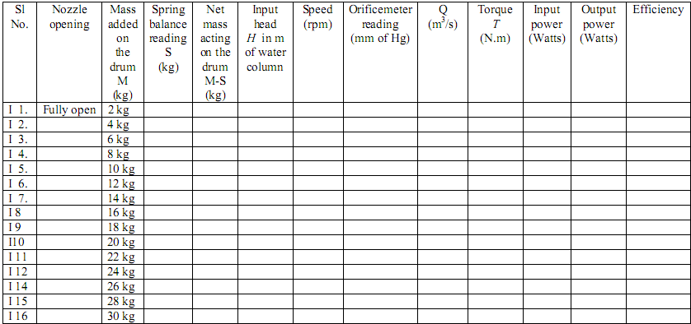

SPECIMEN CALCULATION
Input power = ρ g Q H
Torque T = (M-S) g x (D+d)/2
Output power = 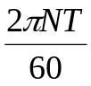
Efficiency = 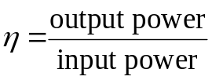

GRAPHS TO BE PLOTTED:
Graph 1: X-axis is Speed; Y-axis is output power and efficiency for fully open nozzle position.
QUIZ:
1) What is Pelton Turbine?

PART – 2
ANIMATION STEPS


PART – 3
VIRTUAL LAB FRAME

